Lab Class: Creating Your First Project in Laravel - Herd
Table of Contents
Based on the Lecture Slides and Support Material
Create a project in Herd
Creating a Blade Component
Using a $slot
Files to retain for next Lab Class
Takeaway thoughts from this Lab Class
Mini Challenge task

Based on the Lecture Slides and Support Material
You may watch the following videos for step-by-step demo and to set the context:
https://laracasts.com/series/30-days-to-learn-laravel-11/episodes/1
The first episode of the "30 Days to Learn Laravel" series on Laracasts introduces viewers to the Laravel PHP framework. The instructor, Jeffrey Way, begins by discussing the benefits of using Laravel, such as its elegant syntax and powerful tools, and then guides the audience through the initial steps of setting up a Laravel project using Herd. Jeffery includes alternative ways to install Laravel. The episode aims to provide a solid foundation for those new to Laravel, ensuring they are well-prepared for the lessons to come. We have Herd installed in all the Computing Lab computers. You can install it on your PC (Mac or Windows). The episode ends up using the Terminal to create an ‘Example’ Laravel app.
https://laracasts.com/series/30-days-to-learn-laravel-11/episodes/2
In Episode 2 of the Laracasts series "30 Days to Learn Laravel," the focus is on setting up and running a basic Laravel application. The episode adds pages to view the routes and starts with the “Helle World” starter. He introduces the Blade templating concept for reusable macros to create the html for the browser.
https://laracasts.com/series/30-days-to-learn-laravel-11/episodes/3
In the third episode of the "30 Days to Learn Laravel 11" series on Laracasts, creates the three page layout: home, contact and about. He will then link the three pages using a simple navigation.

Create a project in Herd
Go to the Herd Directory and type the following command
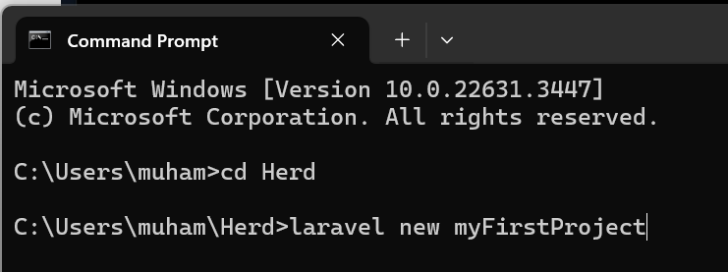
Select “none” in the start kit
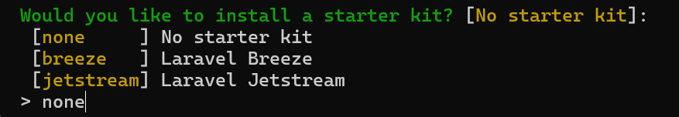
Select the default testing framework
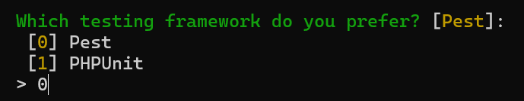
Select no for the Git repository
Select SQLite in the database option
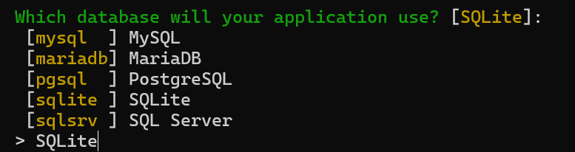
Congratulations. Your first project is complete. Now to go a browser and type myFirstProject.test to see the output.

To open you project in Visual Studio Code, go to the file menu and click on ‘Open Folder’
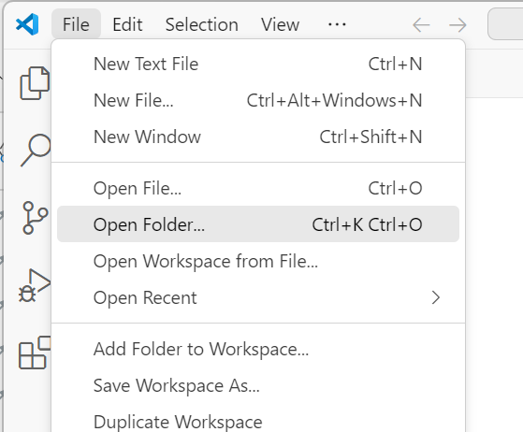
Select the project folder. The default location is the project name folder inside the Herd directory. This will open your project.
Now if you go to the web.php in the routes, you will see the following code
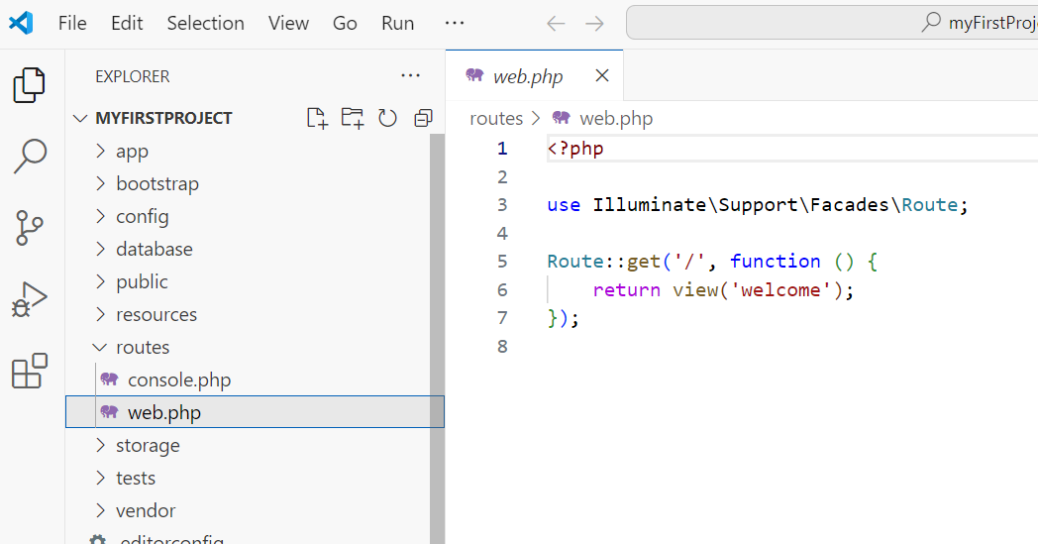
Here in this code ‘/’ means the home directory which means the welcome view will appear when we type the project link in the browser.

Clicking on welcome.blade.php will take you to the markup of the home page
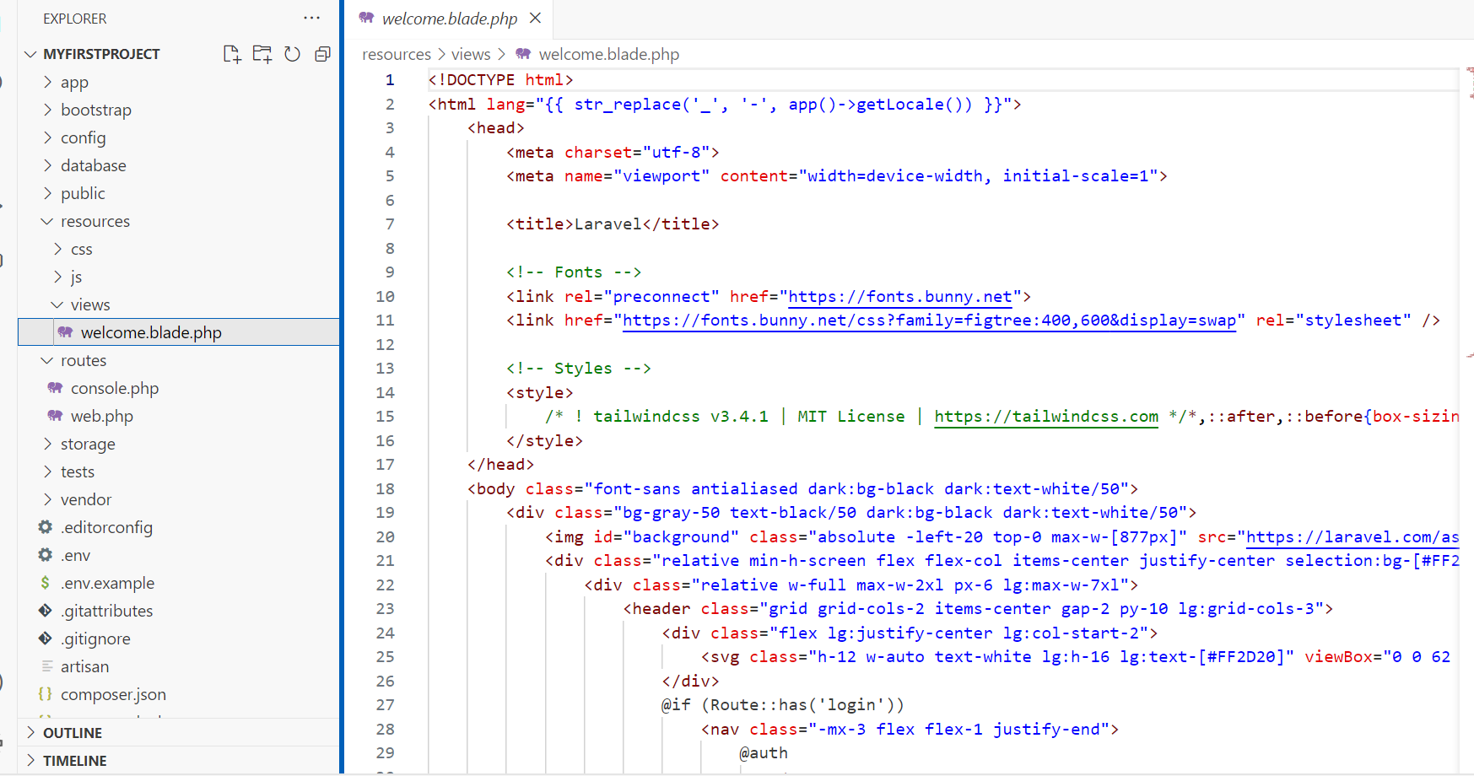
Now let’s change the home page.
Delete everything in the body tag and replace it with
<h1>Hello World</h1>
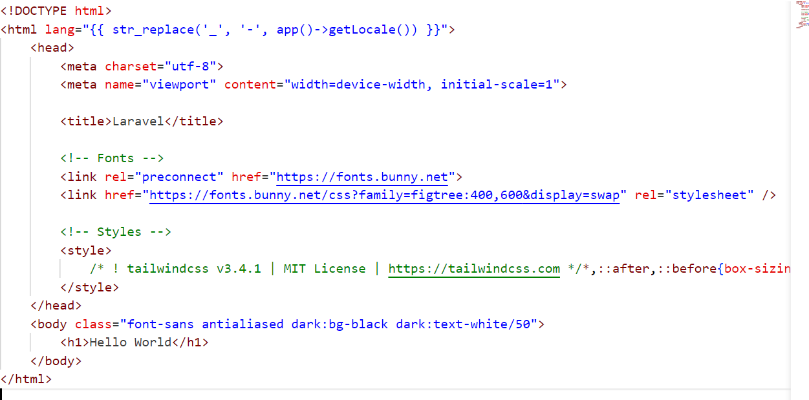
Now type http://myfirstproject.test/ in your browser and you will see the changed home screen.
Let’s create another route for ‘about’ page
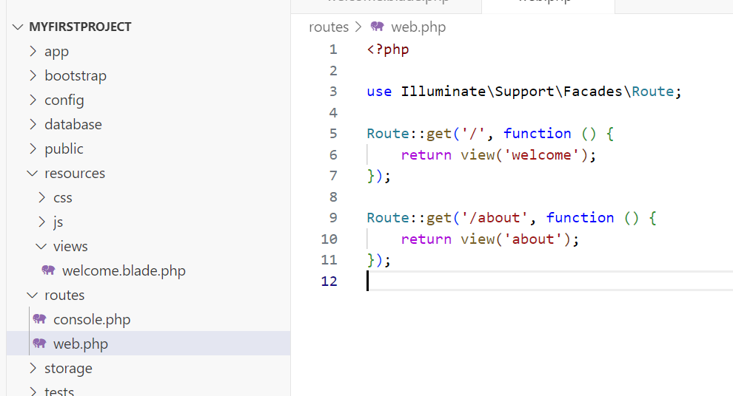

Now let’s create the ‘about’ view
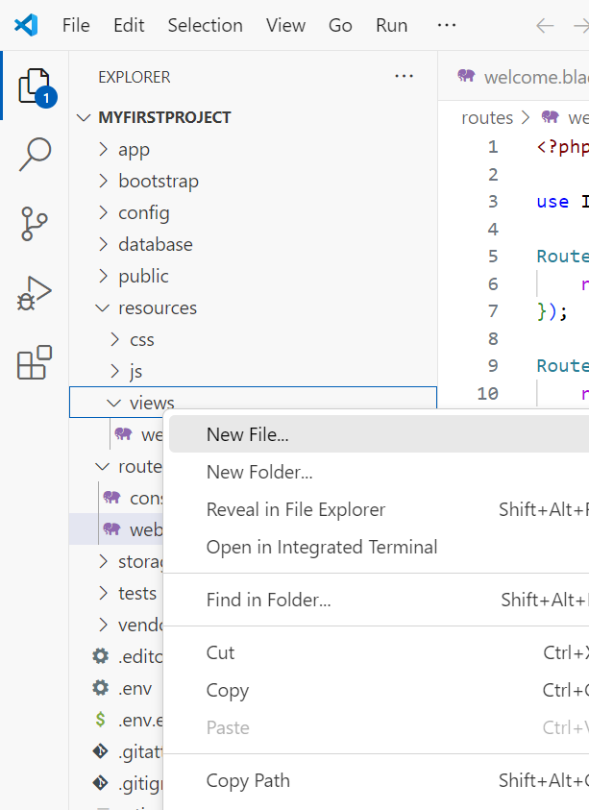

Just start typing html:5 and the file will be populated with some HTML code.

Change the title and body as follow:
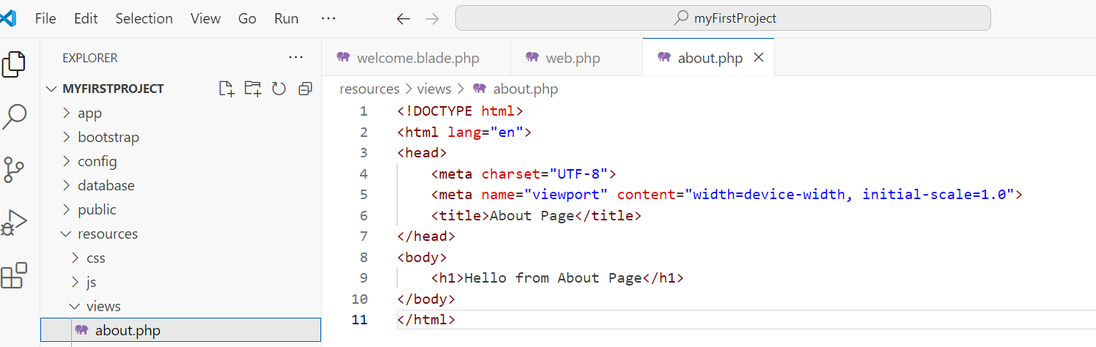
Save your project from the file menu by clicking on ‘Save All’. Now type the following in your browser and you will see the about page.
http://myfirstproject.test/about
Let’s add another page for ‘contact’ as follows:
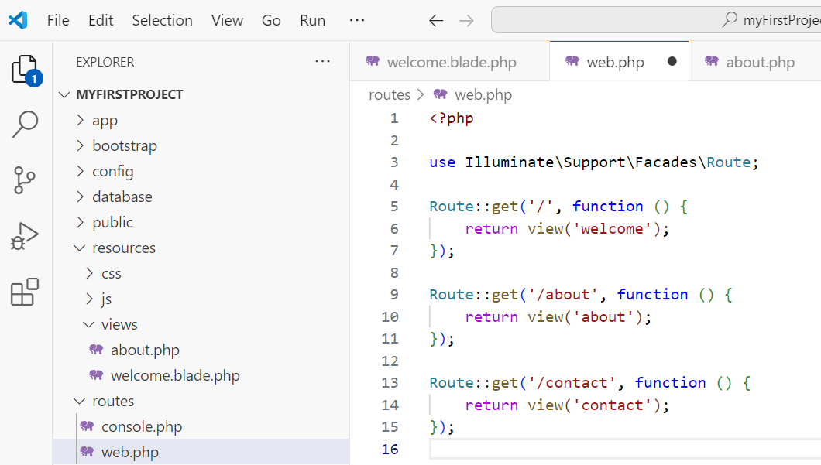

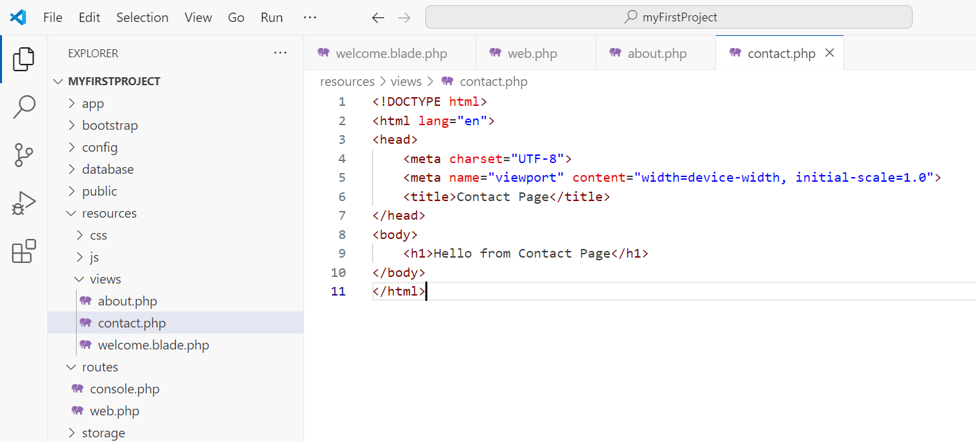

Test your new page by typing the following in the browser
http://myfirstproject.test/contact
now, to make things consistent let’s change the view ‘welcome’ to ‘home’ and populate it with similar code as that of the other two pages: ‘about’ and ‘contact’.

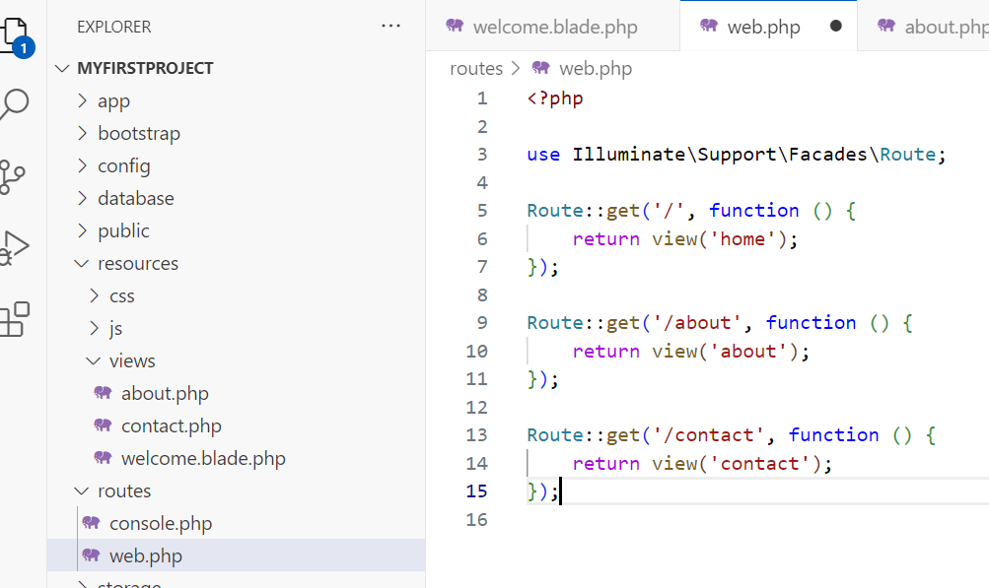
Now let’s add some navigation to the home page.
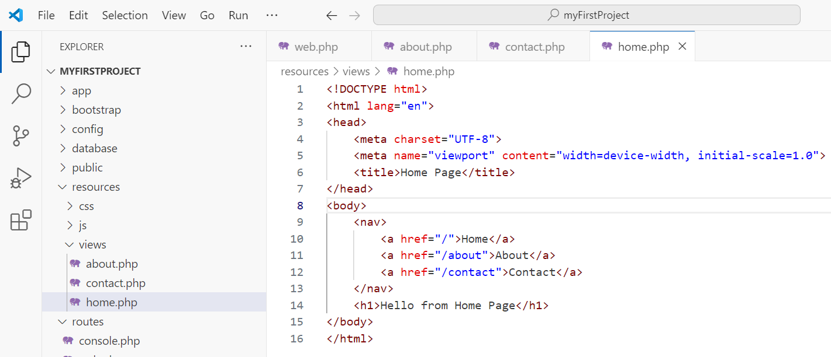

Go to the ‘home’ page by typing http://myfirstproject.test/ in the browser to see the navigation on home page.
If you notice, we see the navigation only on home page. A naïve solution to this would be to add this navigation to all pages (home, about, contact) but there is a better way to do this.
First change the views names by including blade as follows
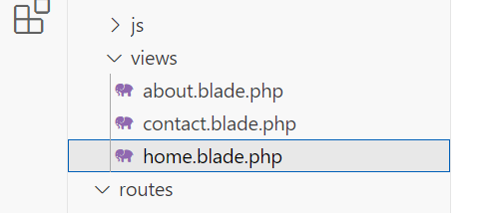

Add a new directory with the name ‘Components’
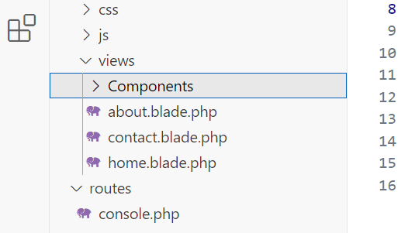
Let’s add a new layout file to the ‘Components’ directory
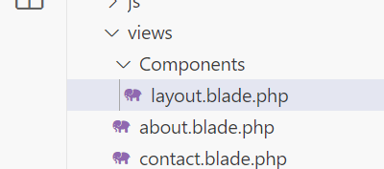

Creating a Blade Component
Copy all the code from ‘home.blade.php’ and paste it in ‘layout.blade.php’
Delete the code from home.blade.php and add the following code to reference the layout file that we just created.
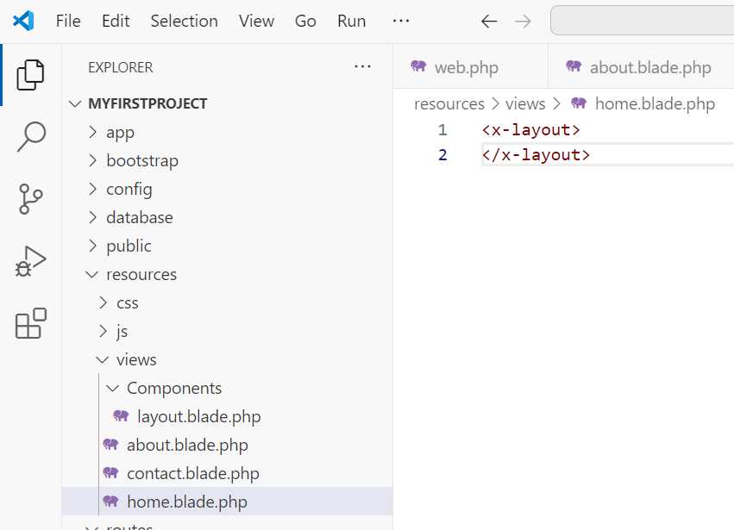

The highlighted text below belongs to the home page only, so we need to move it to the home page from the layout.
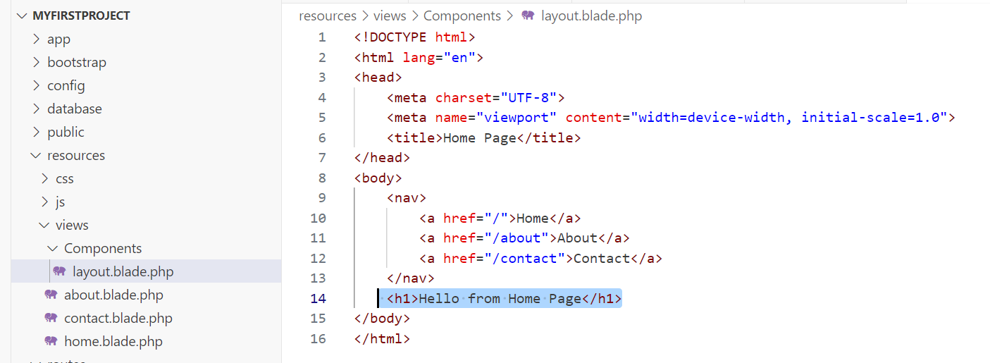

Using a $slot
We will modify the layout file as follows
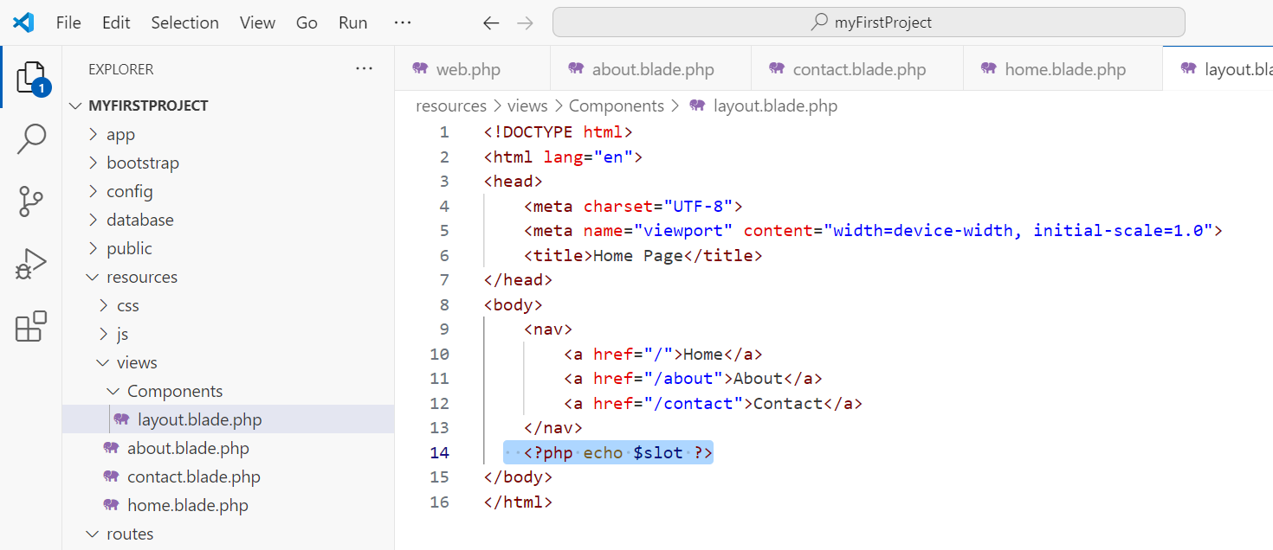
slot is a special variable which guides where the specific code from a page should be displayed.
Also, modify the home view as follows:
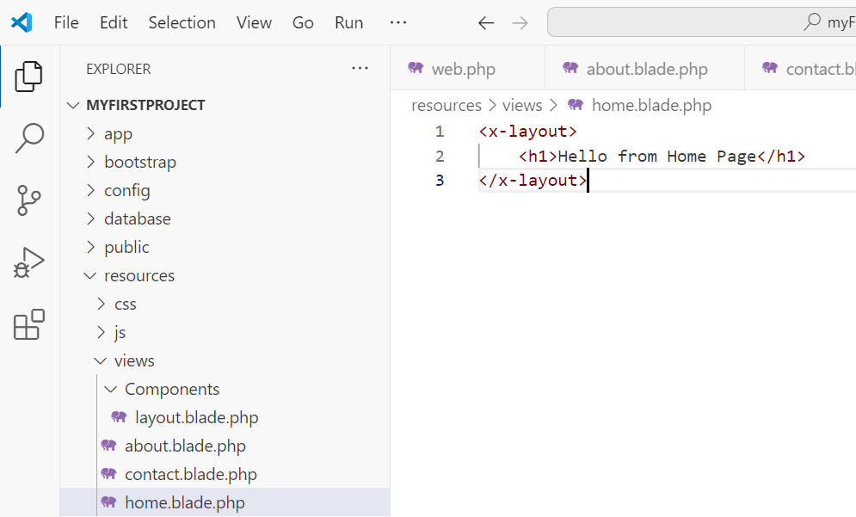
Save all and test your application in the browser.

Now, we can modify out ‘about’ and ‘contact’ pages as well to utilize the layout file.
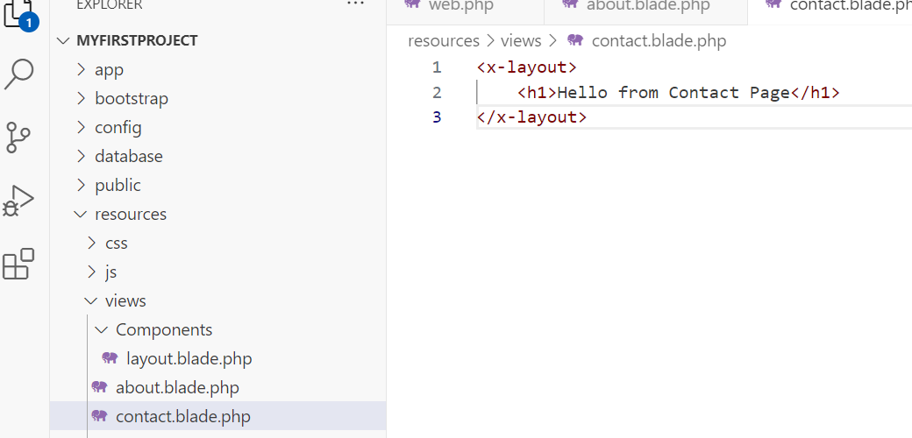
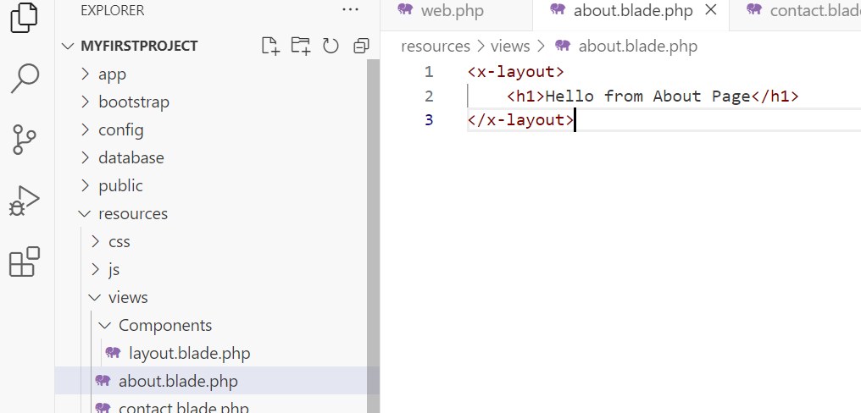

We can simplify the <?php echo $slot ?> in our layout file to {{$slot}} as we are using blade.
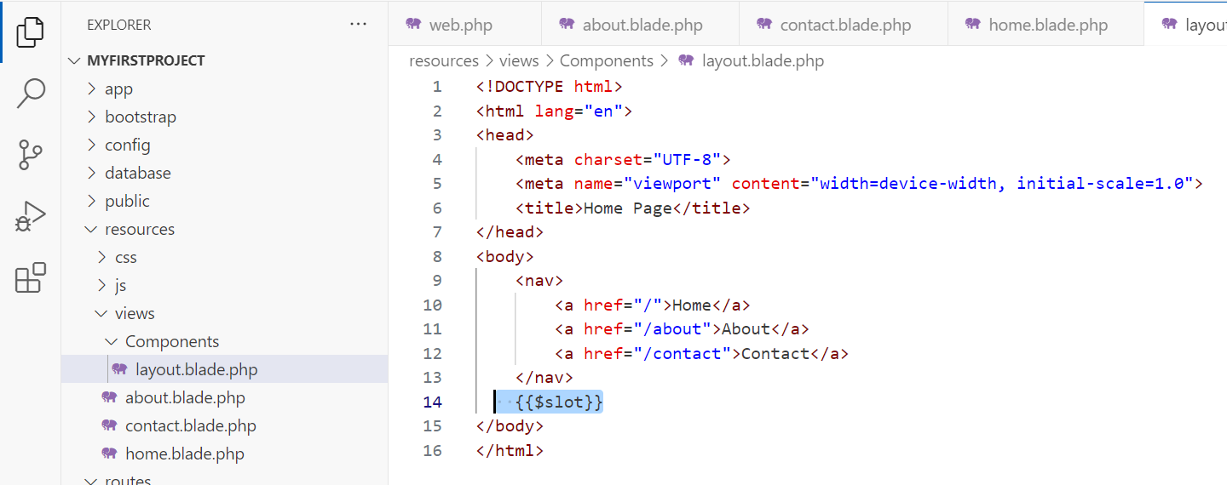

Files to retain for next Lab Class
web.php
views folder

Takeaway thoughts from this Lab Class
How to set up a basic Laravel Herd project
Making use of:
Routes
Views
Adding simple PHP to the HTML
Recognising that
<?php echo $slot ?>
is the same as
{{$slot}}
when using Blade helper templating {{ }}
Refactoring recurring/duplicate elements and using the <x- > component, for example:
<x-layout> with {{$slot}} to make pages dynamic.

Mini Challenge task
Extract all the anchor navigation elements into a component called nav-link using slots to allow the three pages to dynamic link as before.

